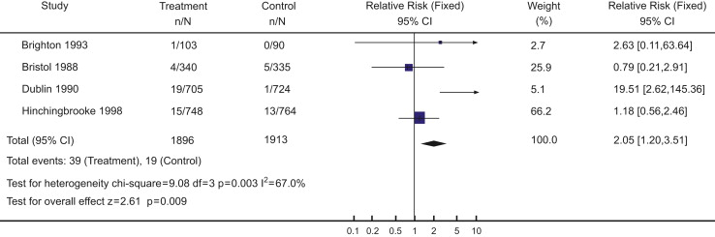
Fig. 1. Comparison of active versus expectant management of the third stage of labour in manual removal of the placenta for women at low risk of postpartum haemorrhage (Prendiville et al., 2000).

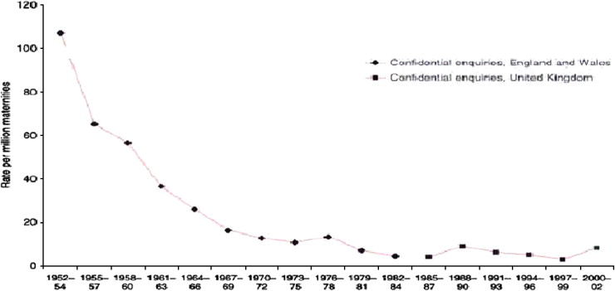
Fig. 2. Maternal mortality for deaths due to haemorrhage: England and Wales 1952–1984 and UK 1984–2002 (CEMACH, 2004).

